Document title

Loren ipsum dolor sit amet, consectetur adipisicing elit, sed do eiusmod tempor incididunt ut labore et dolore magna aliqua.

# Chapter Title

## Section

Let’s test a citation here (Schlichting & Levin 1988; Schlichting 1989). These citekeys come from the bibtek file of all your references specified in the YAML metadata. If using Sublime to edit markdown, you can cite quickly using [Papers](http://www.papersapp.com/mac/) by hitting CTRL twice. Or there are two Sublime packages [Citer](https://packagecontrol.io/packages/Citer) and [CiteBibtex](https://packagecontrol.io/packages/CiteBibtex) that may help. For citations to work, you also have to run the pandoc-citeproc filter, either via panzer style or pandoc commandline options. Finally, you need to specify a citation style csl file in the metadata. See [pandoc citations](http://pandoc.org/README.html#citations) for more information.

### Subsection: Some text examples

* *italics*
* **bold text**
* ~~strikethrough~~
* superscript: Q2
* subscript: H2O

#### Subsubsection

## Tables

Pandoc markdown supports [several different kinds of tables](http://pandoc.org/README.html#tables). Thus far, there is no easy way to set up styles in word for them. They can be referenced in text though using [pandoc-tablenos](https://github.com/tomduck/pandoc-tablenos) or [pandoc-crossref filters](https://github.com/lierdakil/pandoc-crossref). For examples refer to tbl. 1, tbl. 2, tbl. 3.

Table 1: Table 1: This is a simple table. You can left, right, and center align cells by controlling the spacing relative to the dashes below column headings.

|  |  |  |  |
| --- | --- | --- | --- |
| Right | Left | Center | Default |
| 12 | 12 | 12 | 12 |
| 123 | 123 | 123 | 123 |
| 1 | 1 | 1 | 1 |

Table 2: Table 2: This is a multi-line table. Multiline tables pay attention to the relative width of columns allowing more control.

|  |  |  |  |
| --- | --- | --- | --- |
| Centered Header | Default Aligned | Right Aligned | Left Aligned |
| First | row | 12.0 | Example of a row that spans multiple lines. |
| Second | row | 5.0 | Here’s another one. Note the blank line between rows. |

Table 3: Table 3: This is a grid table. Grid tables allow for multiple paragraphs, code blocks, lists etc. within a cell.

|  |  |  |
| --- | --- | --- |
| Fruit | Price | Advantages |
| Bananas | $1.34 | * built-in wrapper * bright color |
| Oranges | $2.10 | * cures scurvy * tasty |

## Figures

The syntax for figures is just like a link, but is preceeded by an exclamation point. You can embed PDFs this way, but currently there is no support for sizing them, so it’s better to use an image format. Images will be displayed at their specified width/height and dpi

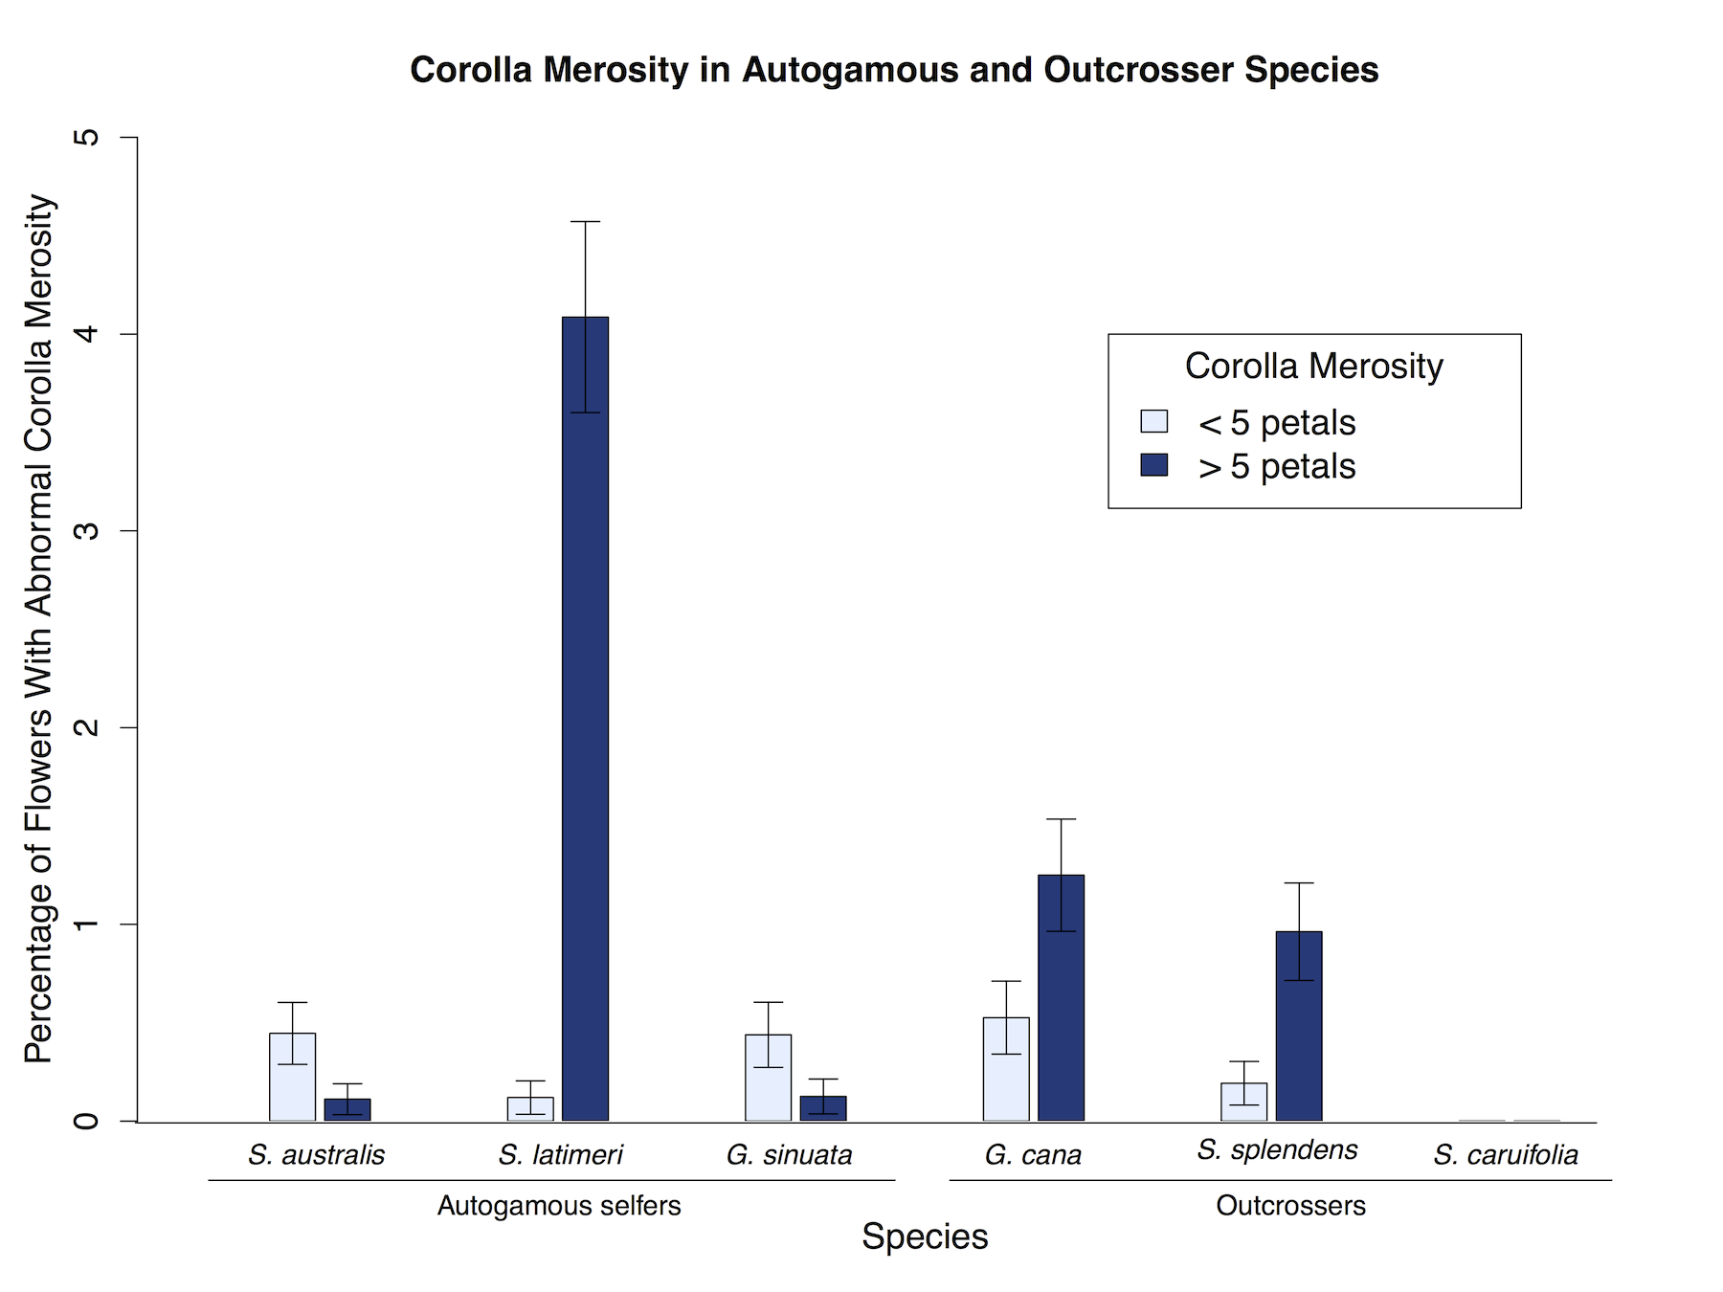

Figure 1: Figure 1: Here’s a caption for our figure.

## Equations

Here’s a complicated equation, written in LaTex: To use this notation, the pandoc commandline option for format has to be changed from *-f markdown* to *-f markdown+tex_math_single_backslash*

$$ϕ_{n}(κ)=\frac{1}{4π^{2}κ^{2}}\int_{0}^{∞}{\frac{sin(κR)}{κR}}\frac{∂}{∂R}\left[R^{2}\frac{∂D_{n}(R)}{∂R}\right] dR$$

You can also write equations by enclosing the statement in 1 or 2 dollar signs:

$$(a^{2}+b^{2}\overset{2}{=})/π$$

{#eq:equation2}

$(a^{2}+b^{2}=^{2})/μ$ {#eq:equation3}

## Code

You can include code fenced on either side by 3 backticks. This will also work with R Markdown, and can be run through knitr before pandoc/panzer.

# Make an empty graph  
plot(0,0)

## Miscellany

Using pandoc-pagebreak filter you can specify a pagebreak for Word and LaTeX

You can refer to sections of the document, for example see the Citation Section. The link to use is lowercase, with spaces replaced by dashes. (see eq. **??**)

Markdown supports bullet points and lists

### Ordered List

1. Item 1
2. Item 2
3. Item 3

### Bullet points

* Fruit
  + Apples
    - Green
    - Red
  + Bananas
  + Pears
* Veggies
  + Tomatoes
  + Broccoli

## References

Schlichting, C. & Levin, D.A., 1988. Phenotypic Plasticity in Phlox. I. Wild and Cultivated Populations of P. drummondii on JSTOR. *American Journal Of Botany*, 75(2), pp.161–169.

Schlichting, C.D., 1989. Phenotypic Plasticity in Phlox. II. Plasticity of Character Correlations. *Oecologia*, 78(4), pp.496–501.